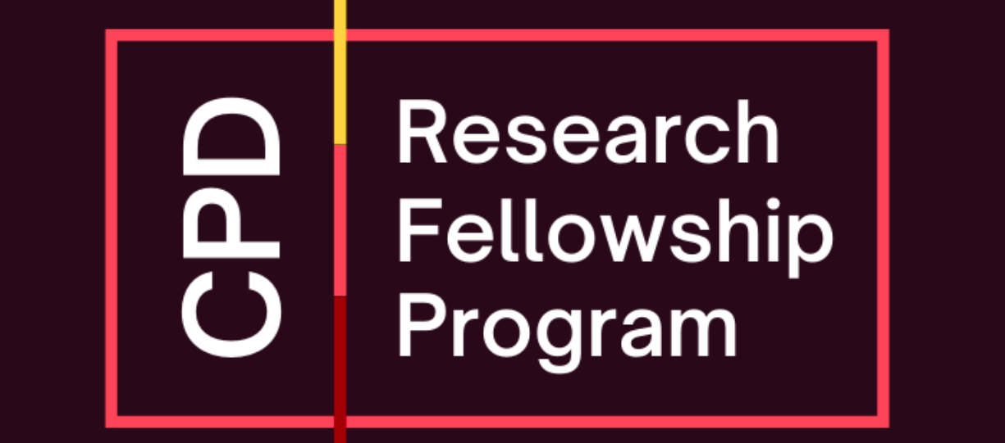
PROGRAM DETAILS
In August 2009, the USC Center on Public Diplomacy (CPD) launched a non-resident Research Fellowship program intended to support and publicize the work of scholars and practitioners of public diplomacy. Three non-resident fellows are selected every year, each serving a two-year term.
CPD Research Fellows will be expected to oversee substantive research projects that will yield at least two outputs, including one publication for the CPD Perspectives on Public Diplomacy series. The second output could consist of a blog series for the CPD Blog, or another type of product that the Fellow develops with the Center. These outputs will be due by June 1, 2026.
CPD welcomes proposals that examine both the historical and contemporary practice of public diplomacy conducted anywhere in the world. Competitive proposals must contribute something new to the growing body of public diplomacy literature. The selected candidates will each receive a $2,000 stipend awarded upon the successful completion of the fellowship. In addition, the Center will offer research assistance as needed from students in the Master of Public Diplomacy (MPD) program or related degree programs at USC.
Applications should be sent electronically to cpd@usc.edu with “ATTN: CPD Research Fellowship Application” in the subject line by 5pm PST on November 15, 2024. See below for application details.
To see a list of current CPD Research Fellows and their projects, click here.
*Please note that USC students and faculty are ineligible for the non-resident CPD Research Fellowship.

APPLICATION
2025-2027 CPD RESEARCH FELLOWSHIP
Please email the application form, a current CV, and a detailed project description per the instructions below to cpd@usc.edu with “ATTN: CPD Research Fellowship Application” in the subject line by 5pm PST on November 15, 2024. All applicants will be notified of CPD’s decision in early 2025.
Name:
Title:
Address:
Phone:
Email:
Project title:
[ ] I agree to the terms outlined above
Detailed Project Description/Proposal
Please attach details of your proposed CPD research project. Research proposals should have direct relevance to public diplomacy issues. The topics may be contemporary or historical and are not limited to any geographic region. Project descriptions should not exceed 4 pages (double spaced) in length. This must specify research questions, agenda, and methodological approach.
Please also include a timeline for all deliverables, highlighting the expected submission dates for a CPD Perspectives on Public Diplomacy paper, CPD Blogs, and other outputs, and indicate whether you expect to receive student research assistance.

