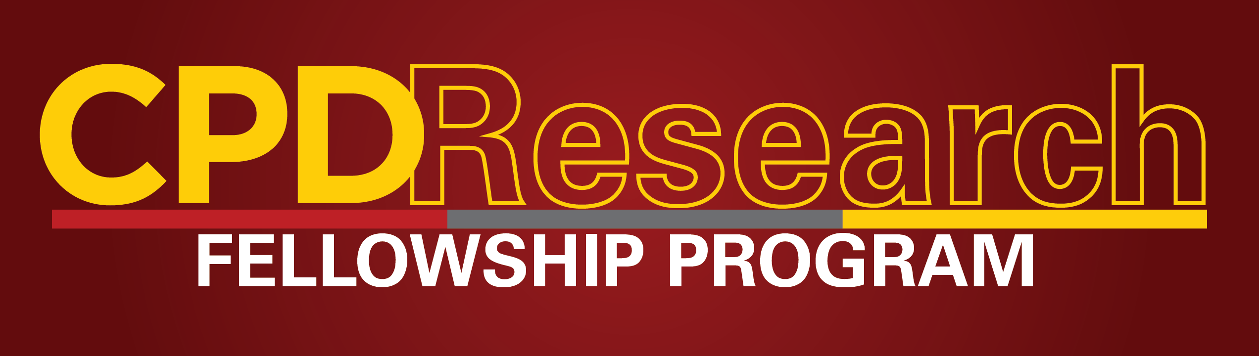
PROGRAM DETAILS
In August 2009, the USC Center on Public Diplomacy (CPD) launched a non-resident Research Fellowship program intended to support and publicize the work of scholars and practitioners of public diplomacy.
CPD Research Fellows oversee substantive research projects that yield at least two outputs, including one publication for the CPD Perspectives on Public Diplomacy series. The second output could consist of a series for the CPD Blog, or another type of product that the Fellow develops with the Center.
As always, CPD welcomes proposals examining both contemporary and historical public diplomacy, conducted anywhere in the world. Competitive proposals must contribute something new to the growing body of public diplomacy literature. The selected candidates will each receive a $2,000 stipend awarded at the successful completion of the fellowship. In addition, the Center will offer research assistance as needed to CPD Research Fellows from students in the Master of Public Diplomacy (MPD) program or related degree programs at USC. Three non-resident fellows will be selected every year, each serving a two-year term.
Applications are due to CPD Deputy Director, Sherine Badawi Walton (sbwalton@usc.edu) by COB on Monday, September 1, 2014. See below for application details.
To see a list of current CPD Research Fellows and their projects, click here.
*Please note that USC students and faculty are ineligible for the non-resident CPD Research Fellowship.

APPLICATION
2014-2016 CPD RESEARCH FELLOWSHIP

Please complete the application form below, attach a current CV and detailed project description per the instructions below and email the full package to CPD Deputy Director, Sherine Badawi Walton (sbwalton@usc.edu) by COB on Monday, September 1, 2014. All applicants will be notified of CPD’s decision in early fall.
Name:
Title:
Address:
Phone:
Email:
Project title:
[ ] I agree to the terms outlined above
Detailed Project Description
In the space below, please attach details of your proposed CPD research project. Project descriptions should not exceed 4 pages (double spaced) in length.
Research proposals should have direct relevance to public diplomacy issues. The topics may be contemporary or historical and are not limited to any geographic region. Please list any project deliverables including the requirements listed in the program description above and indicate whether you expect to receive student research assistance.

